1.

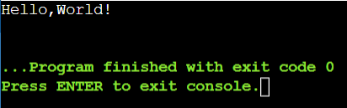

2.

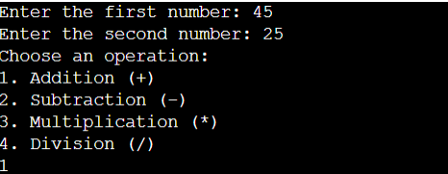

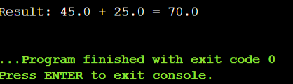

3.



4.

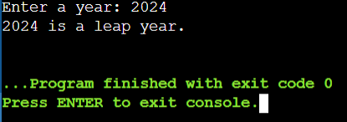

5.

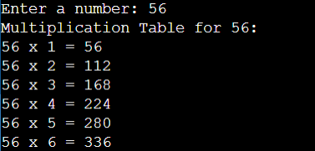

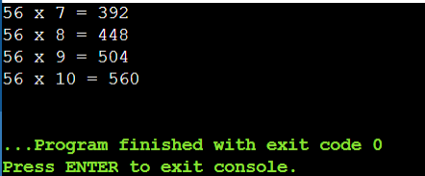

6.

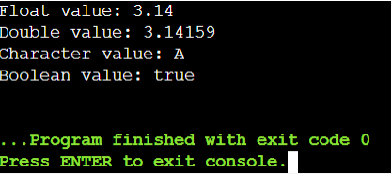

7.

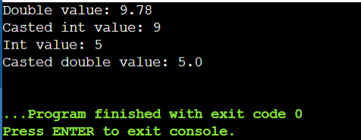

8.

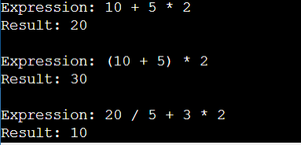

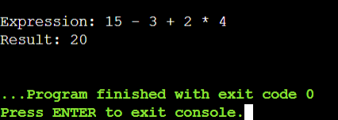

9.

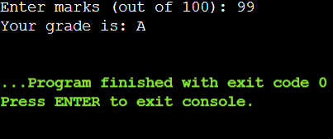

10.

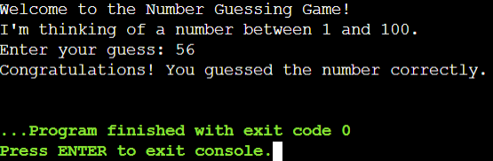

11.

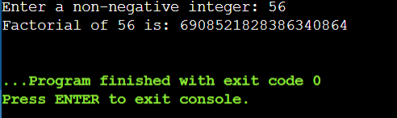

12.

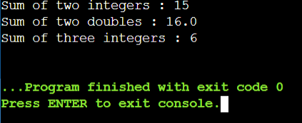

13.

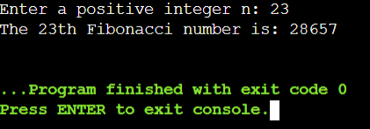

14.

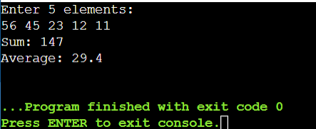

15.

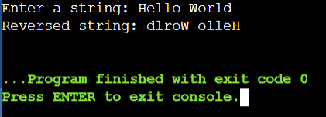

16.

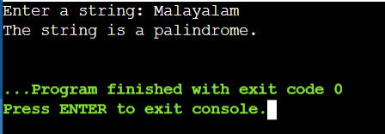

17.

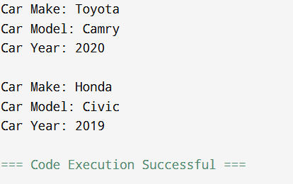

18.

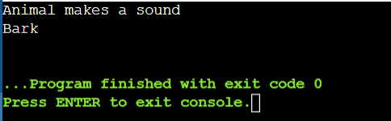

19.

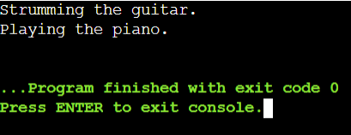

20.

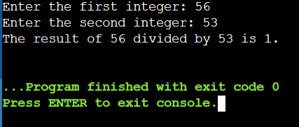

21.

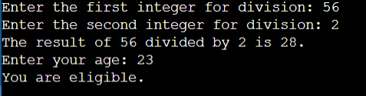

22.

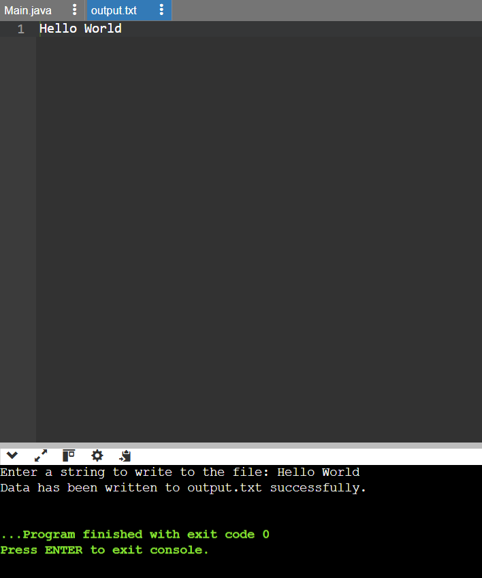

23.

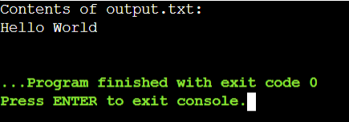

24.

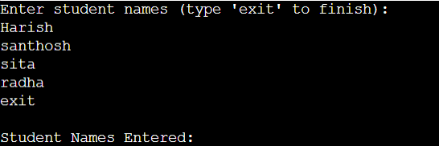

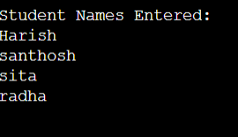

25.

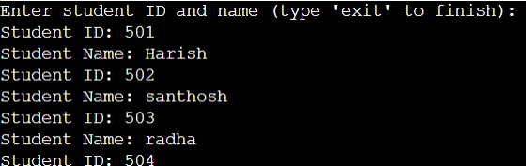

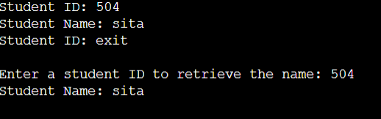

26.

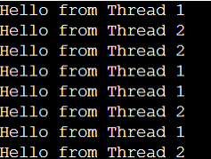

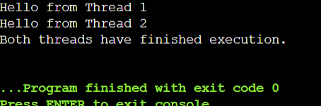

27.

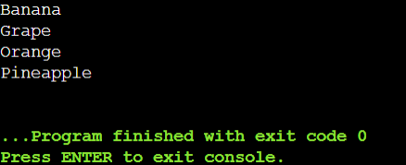

28.

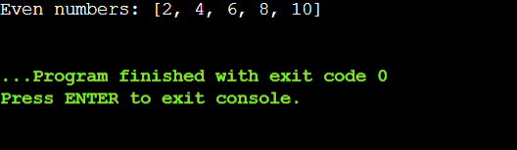

29.

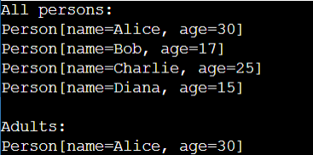

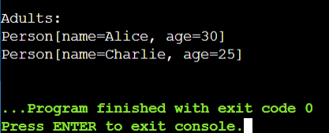

30.

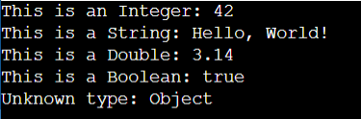

31.

Table:

|  |  |  |
| --- | --- | --- |
| Id | Name | Grade |
| 1 | Alice | 85.5 |
| 2 | Bob | 90.2 |

Connection established successfully.

ID: 1, Name: Alice, Grade: 85.5

ID: 2, Name: Bob, Grade: 90.2

32.

Student inserted successfully.

Rows updated: 1

33.

Transaction successful.

34.

Hello, Alice!

35.

Server started. Waiting for client...

Client connected!

Client: Hello

You: Hi there!

Connected to server.

Server: Hi there!

36. Status Code: 200

Body: {

"login": "octocat",

"id": 583231,

"node_id": "...",

...

}

37. Compiled from "SampleClass.java"

public class SampleClass {

public int add(int, int);

Code:

0: iload_1

1: iload_2

2: iadd

3: ireturn

}

38.

Hello, Java!

39.

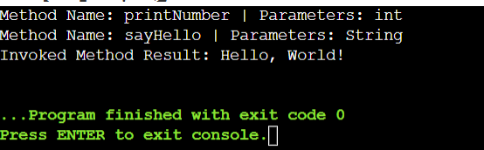

40.

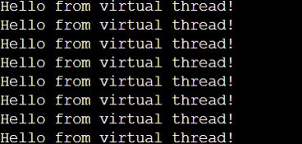

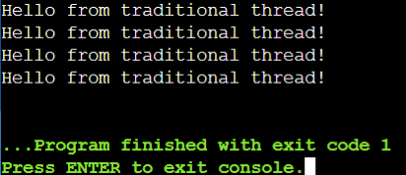

41.

